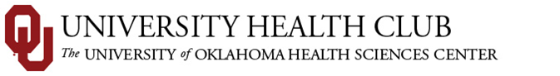
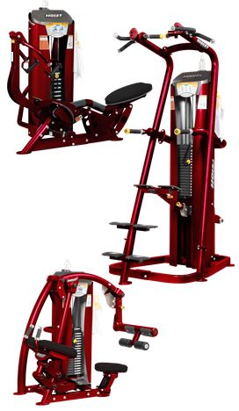

Weight Machines 101

This FREE one-time class is a tutorial on how to use our new Hoist Roc-It selectorized weight machines.
Class size: Limited to 8 people
Class time: 30-45 minutes
Dates & times – You choose one of the following class times.
Classes will be available at 8:30am, 12:00pm, & 6:30pm on the following dates:
March 31st • April 8th • April 16th • April 24th
Register at the front desk!

