The University of Oklahoma
Health Sciences Center

UNIVERSITY HEALTH CLUB

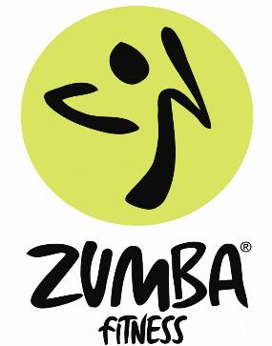

ZUMBA is a premier dance and workout routine.
The only requirement is to “have fun”!

What is Zumba? Zumba is a fusion of Latin and International music and dance themes creating a dynamic, exciting, and effective fitness program. The routines feature aerobic/fitness interval training with a combination of fast and slow rhythms that tone and sculpt the entire body to create a one of a kind workout. Zumba uses the principles of interval training and resistance training to maximize calories burned, fat burning, and total body toning (which we all want!). Zumba targets areas of the body such as glutes, legs, arms, abs, and the most important muscle … your heart! The routines feature aerobic/fitness interval training with a combination of fast and slow rhythms that tone and sculpt the entire body.

Zumba is a mix of body sculpting movements with easy to follow dance steps like the merengue, salsa, cumbia, mambo, samba, and flamenco as well as other dances from around the world including hip hop and belly dance. The dances are set to toe tapping, hip swiveling, arm swinging, high energy Latin Music that just makes you want to get up and mooovvve. Zumba is easy, fun, and an excellent exercise and … you don’t even feel like you are exercising! It is definitely a “party” atmosphere which is less intimidating for people who may not be as coordinated as others. It is a “feel good” workout where you can dance your woes away. Zumba means “to move fast and have fun” and that’s exactly what happens!

When: 6 Week session
Saturday, October 6 through November 20, 2010.

Time: Wednesday 6:00pm - 6:45pm
Saturday 11:30am - 12:15pm

Cost: $25.00/session for members
$55.00/session for non-members

1000 North Lincoln Boulevard (405) 271-1650 www.ouhsc.edu/uhc/
The University of Oklahoma is an equal opportunity institution.

